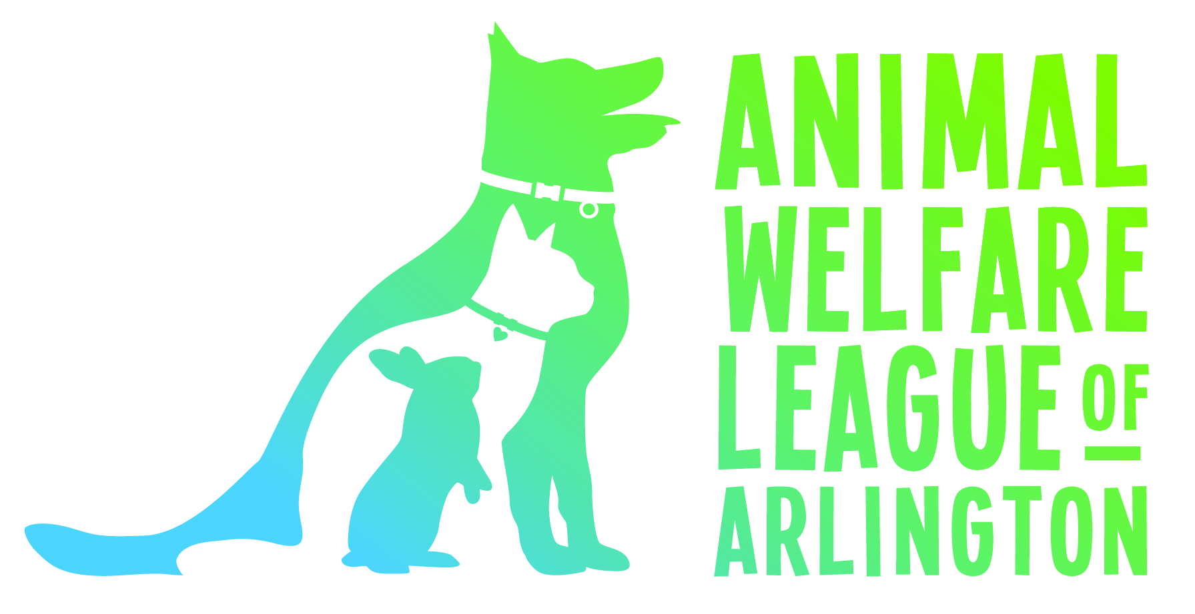
Operating an animal shelter is expensive. Your support, whether financial or in-kind, enables the League to help more animals and their owners.

Items that we use regularly (and a few pie-in-the-sky things) are listed below. All items donated to the League are tax deductible and can be dropped off at or shipped to the front office during business hours. For shelter information visit www.awla.org or if you have a question about a donation, please call us at (703) 931-9241, or email mail@awla.org. Thank you very much!!
In-Kind Donation Wish List
CATS  - Cat Catch the LED Light Interactive Exercise Toy  - Comfort Zone Feliway Refill  - Ethical Skinneeez Mouse Cat Toy  - Fat Cat Big Mama’s Scratch’n’Play Ramp for Cats  - Feline Greenies Pill Pockets Cat Treats, Salmon  - GoCat Da Bird Pull Apart Rod and Bird Cat Toy  - Incline Scratcher Pet Scratch Pad  - MidWest Deluxe Bolster Pet Bed for Dogs & Cats (18 & 22”)  - Milliard Premium Plush Pet Cave/Igloo (14”)  - Nylon Safe Cat Adjustable Breakaway Collar w/ Bell  - Petmate Jumbo Litter Pan  - PetSafe Egg-Cersizer Meal Dispensing Cat Toy  - Precious Cat Cat Attract Problem Cat Training Litter  - Precious Cat Ultra Litter Attractant  - Purina Friskies Pate Chicken & Tuna Dinner Cat Food  - Purina Friskies Pate Liver & Chicken Dinner Cat Food  - Scamp Non-Clumping Cat Litter  - Yesterday’s News Unscented Non-clumping Cat Litter  DOGS  - Cesar Savory Delights Variety Pack Chicken & Filet Mignon  - Greenies Pill Pockets Soft Dog Treats, Hickory Smoke  - Kong Puppy Stuff’n’Ziggies Small Dog Treat  - Kong Wobbler Treat Dispensing Toy, Large  - Libby’s Vienna Sausage in Chicken Broth  - Natural Balance Dog Food Roll, Beef Formula  - Pet Botanics Training Rewards Mini Treats, Dogs, Chicken  - PetSafe Deluxe Easy Walk Harness Medium/Large & Large  - PetSafe Martingale Collar, 3/8” Petite & ¾” Medium  - Purina Fortiflora Canine Nutritional Supplement  - Purina SmartBlend Tender Cuts, Gravy, Chix & Brown Rice  - Purina SmartBlend Wet Dog Food, Tender Cuts, Variety  - Redbarn Bully Sticks (7 & 12”)  - Stewart Freeze Dried Treats, Beef Liver  - T-Bonz Porterhouse Flavor Dog Snacks  KITTENS  - Breeders Edge Foster Care Feline Powdered Milk Replacer  - Purina Fortiflora Feline Nutrition Supplement  - Royal Canine or Baby Cat Canned or Dry Food  - Snuggle Safe Pet Bed Microwave Heating Pad | SMALL COMPANION ANIMALS  - Kaytee Grassy Roll-a-Nest Hideout, Large  - Kaytee Woodland Get-A-Way Medium Hamster House  - Kaytee Nut Knot Nibbler, Medium  - Wesco Pet Original Bird Kabob Shreddable Bird Toy  - Ecotrition Snak Shak Guinea Pigs and Rabbits House, Large  - Super Bird Creations ½”x 52” Rope Bungee Bird Toy, Small  - Paradise Toys Cotton Preening Doll, 6” W x 12” L  - Paradise Toys Knots’n’Blocks, Large 6” W x 16” L  - Oxbow Timothy Carrot for Pets  - Oxbow Timothy Club Timothy Mat for Pets, Medium  - Oxbow Simple Rewards Baked Treats, Apple & Banana 2oz.  - Ware Manufacturing Willow Branch Ball for Small Animals  - Medium Crazy Color Rabbit Chew Toy  - Peter’s Woven Grass Play Ball for Rabbits  - Colorful Plastic Pet Toy Ball w/ Bell, Dog Cat Rabbit Bauble  - Wild Harvest Colored Wood Chews for Small Animals  - Barrel Roller Small Animal Chew  - Bunny Blast Yucca Chew Toy  - Carefresh Colorful Creations Small Pet Bedding  - Carefresh Natural Premium Soft Pet Bedding  - Lee’s Herp Havens (Small/Medium/Large)  ANIMAL CONTROL  - Plastic Tarps  - Zip Ties  - Small, Portable Fire Extinguishers  - Portable First Aid Kits  - Microchip Scanners  OTHER  - GoPro Camera (new or used)  - Laptops (new or used)  - iPads (new or used)  - Animal Crates & Carriers (clean; gently used)  - Towels (clean; gently used)  - Gift Cards – Target/HomeDepot/Staples/PetsMart/Amazon  Most items available on AWLA's Amazon Wish List  To make a financial donation click here!

We regret that we CANNOT take the following items:
Pillows / Sheets / Plastic Dishes / Used Cat Scratchers & Litterboxes / Used or XL Dog Beds / Rx Medications

